**PAGE 2 OF 2: McGill 3 Core Exercises**

**HOLD SIX SECONDS. REPEAT SIX TIMES**

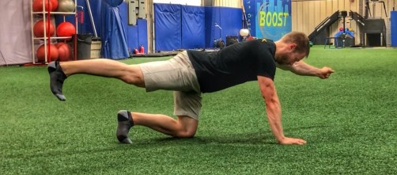

**Bird Dog**

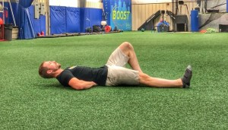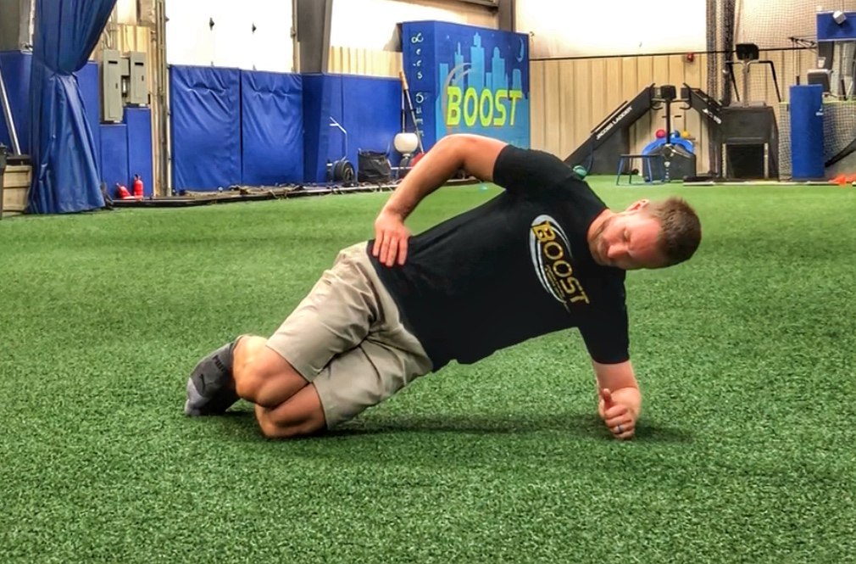

**Curl Up**

**Side Plank**

**PAGE 1 OF 2**

**HOLD SIX SECONDS. REPEAT SIX TIMES**

**WARM-UP STRETCH**

**ANGRY CAT & CAMEL**

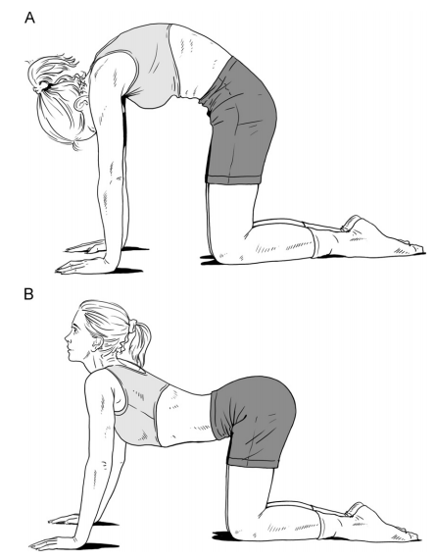

**Abdominal Bracing. Tighten side abdominal muscles and maintain breathing. Dial it stronger or lighter depending upon activity. Always perform an abdominal brace before lifting, carrying, pushing, pulling, bending, reaching and strengthening exercises. DO NOT Hold your breath! NEVER TWIST!**

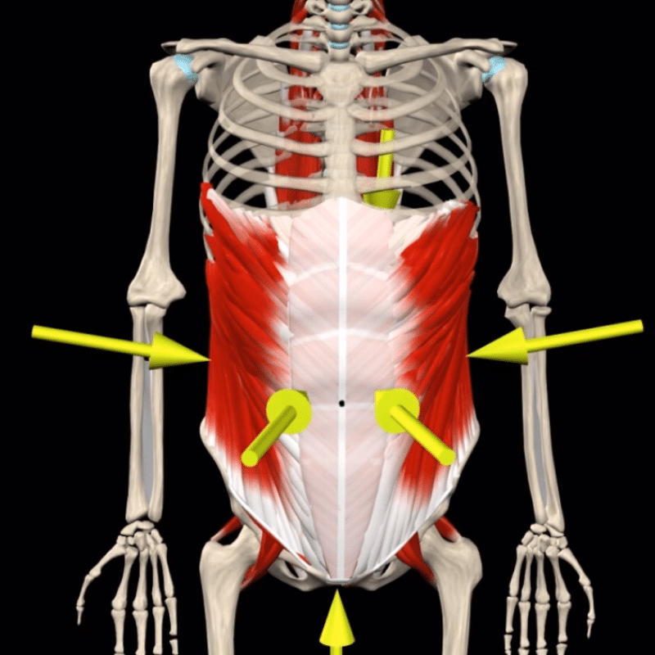

**TURN ON YOUR NATURAL BACK BELT**